**ES 331 Probability and Random Processes**

**Assignment 4**

**Name:** Girish Chandar G

**Roll No:** 16110057

**Aim:**

To restore a corrupt image by implementing a wiener filter.

**Theory:**

Wiener filter is used to remove blur caused due to linear motion or unfocussed optics. Let

$f(x,y)$ be the uncorrupt image

$F(u,v)$ be the Fourier transform of the uncorrupt image

$h(x,y)$ be the point spread function

$H(u,v)$ be the Fourier transform of the point spread function

$n(x,y)$ be the additive noise

$N(u,v)$ be the Fourier transform of the noise

$g(x,y)$ be the corrupt image

$G(u,v)$ be the Fourier transform of the corrupt image

Then the following formula can be used for implementing the wiener filter.

$$W(u,v)=\frac{H^{*}(u,v)}{{|H(u,v)|}^{2}+K(u,v)}$$

where, $K(u,v)$ is the ratio of PSD of noise and PSD of uncorrupt image

$$K(u,v)=\frac{{|N(u,v)|}^{2}}{{|F(u,v)|}^{2}}$$

**Procedure:**

1. **Estimation of $K(u,v)$** :
   1. To estimate $K(u,v)$ 10 grayscale(512x512) images were used.
   2. A gaussian blur with standard deviation of 10 and kernel size of 5x5 was applied.
   3. A additive white gaussian noise of mean of 0 and variance of 0.01 was added to the blurred image.
   4. $N\left(u,v\right)$ and $F(u,v)$ were calculated for each image by using the inbuilt function in MATLAB(fft2()).
   5. $K(u,v)$ for each of the 10 images was calculated and the average stored for testing.
2. **Implementation of Wiener Filter:**
   1. 5 grayscale(512x512) images were used for testing.
   2. A gaussian blur with standard deviation of 10 and kernel size of 5x5 was applied.
   3. A additive white gaussian noise of mean of 0 and variance of 0.01 was added to the blurred image.
   4. The Fourier transform of the corrupt image($G(u,v)$) and the point spread function were calculated($H(u,v)$)
   5. $W(u,v)$ is found by the formula above for which the $K\left(u,v\right)$ used is the one estimated before.

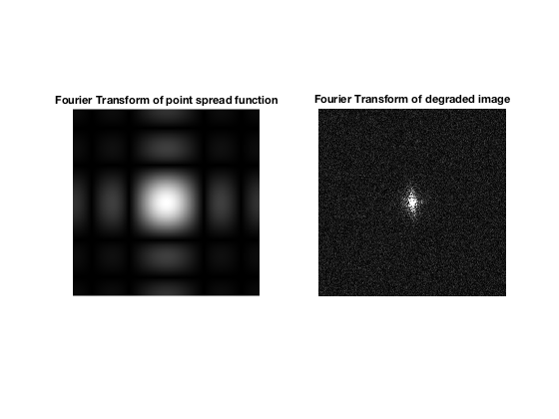

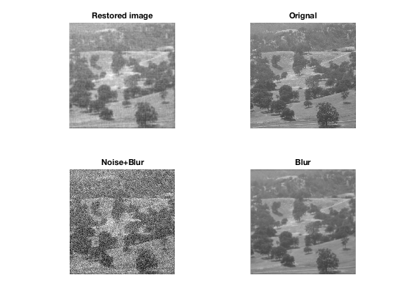

**Results:**

|  |  |  |  |
| --- | --- | --- | --- |
| Image No | PSNR(Restored image) | PSNR(Corrupt image) | Increment in PSNR |
| 1 | 24.895062 | 19.699579 | 5.195483 |
| 2 | 26.942488 | 19.755104 | 7.187383 |
| 3 | 25.177608 | 19.611743 | 5.565866 |
| 4 | 24.900558 | 19.393619 | 5.506938 |
| 5 | 26.260437 | 19.585012 | 6.675425 |

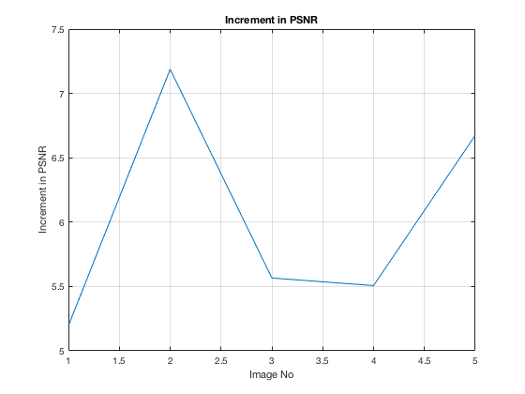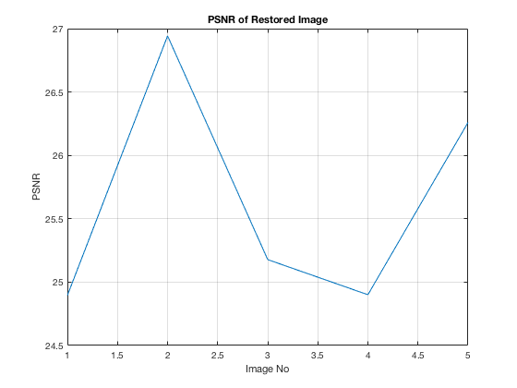

**References:**

* Intuitive Probability and Random Processes using MATLAB
* Dataset: [Dataset of standard 512x512 grayscale images](http://decsai.ugr.es/cvg/CG/base.htm)
* [B14 Image Analysis, Andrew Zisserman, University of Oxford, Lecture 3](B14%20Image%20Analysis,%20Andrew%20Zisserman,%20University%20of%20Oxford)
* MATLAB documentation <https://in.mathworks.com>